Co-Sponsored Session: Queer Studies in Religion and Disabilities Studies
Allyship – Advocacy – Accessibility in Disability Studies

A History of Disability Studies:
The academic field of Disability Studies arose primarily from the disability activist movement of the 1960s and 1970s in the United States and the UK.

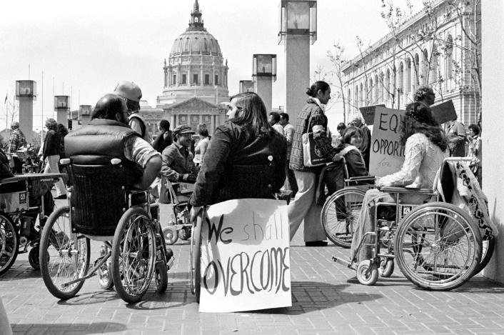
Pictured: Protestors in favor of signing Section 504 in 1977. Most are wheelchair users and have signs saying things like, “We shall overcome” or “Equal Opportunity.” Photo by Anthony Tusler via Atlas Obscura. Find photo here.

Americans with Disabilities Act, signed by President George H.W. Bush in 1990, offers protection of disabled people’s civil rights and prohibits discrimination against them while providing definitions of disability.
“A person with a disability is someone who:
- has a physical or mental impairment that substantially limits one or more major life activities,
- has a history or record of such an impairment (such as cancer that is in remission), or
- is perceived by others as having such an impairment (such as a person who has scars from a severe burn).”

Disability itself does not discriminate and so is intersectional by nature. Looking at the participants of the 1977 Section 504 protest is a terrific example. People of all backgrounds participated, and Black Panthers helped protestors sustain their sit-in energy by bringing them food and other supplies. Disability studies as a field should not remain homogenous and should reflect all peoples’ experiences.

On My Reading List:
Hardwick, Lamar. Disability and the Church: A Vision for Diversity and Inclusion, Downers Grove, IL: InterVarsity Press, 2021.
Soon, Isaac T. “Disability and New Testament Studies: Reflections, Trajectories, and Possibilities.” Journal of Disability & Religion 25 no. 4 (2021): 374-387.
Imhoff, Sarah. “Why Disability Studies Needs to Take Religion Seriously.” Religions 8 no. 186 (2017): 1-12.

Allyship – Advocacy – Accessibility in Queer Studies

A History of Queer
The word Queer is an umbrella term which is used to describe people who are not heterosexual, cisgendered. The word originally was used to mean “strange, peculiar, eccentric.” It became a derogatory term during the 19th Century being linked to ‘wrongness’ and ‘perversion’.
The 1980s saw Activists from the LGBT community to reclaim the word and title. Which is where in 2022, Queer is a board spectrum term that includes sexualities and/or gender identities, histories, politics, and practices that exist outside of the heteronormative agenda.

A History of Queer Studies
Queer Studies was originally created to center on LGBT history and literary theory. Today it now includes all academic disciplines and fields in the examination of identity, lives, history, and perception of queer people.
Mildred Berryman’s 1930’s “The Psychological Phenomena of the Homosexual” is a seminal text in the academic focus on the Queer Community. In 1970, UC Berkeley held the first Undergraduate course on LGBTQ history. City University of New York created the first Gay and Lesbian Studies Program which started in 1986. Three years later, City College of San Francisco, established the first Gay and Lesbian Studies Department.
Now, countless universities and colleges host Queer Studies, Gender Studies, and Sexualities Studies programs, departments, majors, and minors.

Naming and Pronouns
Many people might go by a name in daily life that is different from their legal name. In creating safe and inclusive spaces, we seek to refer to people by the names that they go by. Pronouns can be a way to affirm someone's gender identity, but they can also be unrelated to a person's identity. Additionally, how you identify in terms of your gender, race, class, sexuality, religion, and dis/ability, among all aspects of your identity, is your choice whether to disclose (e.g., should it come up in classroom conversation about our experiences and perspectives) and should be self-identified, not presumed or imposed.
Simple Practice: Ask a person their name and how they would like to be addressed. You can even include it into how you introduce yourself.
Example: “Hi, my name is Anjeanette, and my pronouns are She/Her. What is your name?”

On My Reading List:
Barker, Meg-John, and Julia Scheele. Queer: A Graphic History. Icon, 2016.
Cartier, Marie. Baby, You Are My Religion: Women, Gay Bars, and Theology before Stonewall. Routledge, Taylor & Francis Group, 2014.
Dabiri, Emma. What White People Can Do next: From Allyship to Coalition. Harper Perennial, 2021.
Shlasko, Davey, and Kai Hofius. Trans Allyship Workbook: Building Skills to Support Trans People in Our Lives. Think Again Training, 2017.
Wilcox, Melissa M. Queer Religiosities: An Introduction to Queer and Transgender Studies in Religion. Rowman and Littlefield, 2021.

Workshop Questions:

What does it mean to create a safe and inclusive space? (academy, society, etc.)

Why does language matter?

How do you define allyship or advocacy?

Speaking out in an environment of “cancel culture:” What questions would you ask about disability studies and religion if you weren’t afraid of being canceled?

What happens when scholars disagree? (Defined categories, terms, identities, methodologies, pedagogies)

“Introduction to the Americans with Disabilities Act,” U.S. Department of Justice, Civil Rights Division, accessed March 14, 2022, beta.ada.gov/topics/into-to-ada/.
https://lgbtq.umd.edu/good-practices-names-and-pronouns

