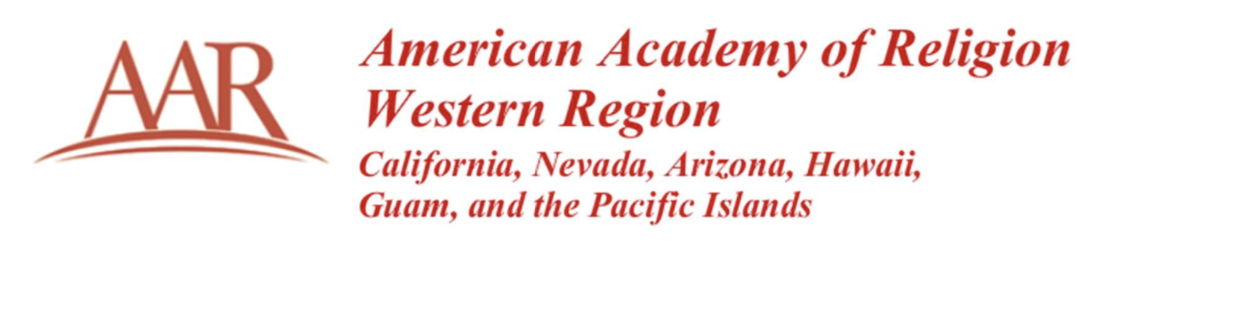
Executive Board Meeting Minutes
March 10, 2023
12:00 pm (PST)
via Zoom
Present:
Emily Silverman
John Erickson
Marie Cartier
Jake Nagasawa
James Berry
Jacob Perez (Conference Manager)
Absent:
Rev. Sakena Young-Scaggs
OLD BUSINESS
- President Welcome & Ice Breaker (John E.)
President Erickson welcomed the group and the executive board participated in an ice breaker activity.

- Policy File Updates (John E.)
President Erickson handed the meeting over to Emily Silverman who discussed the Policy File Committee recommendations and what the committee met and discussed. The recommendation was to take the full set of recommendations to the full board for review and next steps. A motion was made by Past President Emily Silverman and seconded by Vice President and Program Chair Marie Cartier and passed unanimously.
NEW BUSINESS
- 2023 UC-Davis Conference Updates (Jacob P.)
Jacob Perez provided updates about the upcoming 2023 AAR/WR Conference at UC Davis. This included discussion about transportation options to and from the airport to the university as well as promoting it and attendance numbers. The executive committee also discussed making sure we promote open board and unit chair positions.
- 2024 UNLV AAR/WR Conference Updates (Jacob P.)
Jacob Perez provided updates pertaining to the upcoming 2024 AAR?WR Conference at UNLV. There will be a further discussion about the contract and direction given to the Regional Coordinator (RC) at the upcoming 2023 AAR/WR Board Meeting for the RC to execute that agreement.
- AAR/WR Website Discussion (Jake N.)
The Board discussed the potential of having AAR assist with or help AAR/WR, and other regions, with their websites to create better continuity. The Executive Committee agreed to take this to the full board for discussion at the upcoming conference.
- Adjournment
The meeting adjourned at 1:00 pm.

